Star Athletica v. Varsity Brands
Supreme Court of the United States
___ U.S. ___
March 22, 2017

STAR ATHLETICA, L.L.C., PETITIONER v. VARSITY BRANDS, INC., et al., RESPONDENTS, on writ of certiorari to the United States Court of Appeals for the Sixth Circuit. Argued October 31, 2016. Decided March 22, 2017. No. 15–866. Vote: 6-2 in favor of respondents Varsity Brands et al. THOMAS delivered the opinion of the Court. GINSBURG filed a concurrence. BREYER filed a dissent in which KENNEDY joined.. The tilde~ mark indicates a ellipsis. Various ciatations and footnotes omitted without notation. This edit by Eric E Johnson; copyright and related rights waived via CC0 https://creativecommons.org/publicdomain/zero/1.0/.

Justice THOMAS delivered the opinion of the Court.
Congress has provided copyright protection for original works of art, but not for industrial designs. The line between art and industrial design, however, is often difficult to draw. This is particularly true when an industrial design incorporates artistic elements. Congress has afforded limited protection for these artistic elements by providing that “pictorial, graphic, or sculptural features” of the “design of a useful article” are eligible for copyright protection as artistic works if those features “can be identified separately from, and are capable of existing independently of, the utilitarian aspects of the article.” 17 U.S.C. §101.
We granted certiorari to resolve widespread disagreement over the proper test for implementing §101’s separate-identification and independent-existence requirements. We hold that a feature incorporated into the design of a useful article is eligible for copyright protection only if the feature (1) can be perceived as a two- or three-dimensional work of art separate from the useful article and (2) would qualify as a protectable pictorial, graphic, or sculptural work—either on its own or fixed in some other tangible medium of expression—if it were imagined separately from the useful article into which it is incorporated. Because that test is satisfied in this case, we affirm.

I

Respondents Varsity Brands, Inc., Varsity Spirit Corporation, and Varsity Spirit Fashions & Supplies, Inc., design, make, and sell cheerleading uniforms. Respondents have obtained or acquired more than 200 U.S. copyright registrations for two-dimensional designs appearing on the surface of their uniforms and other garments. These designs are primarily “combinations, positionings, and arrangements of elements” that include “chevrons . . . , lines, curves, stripes, angles, diagonals, inverted [chevrons], coloring, and shapes.” At issue in this case are Designs 299A, 299B, 074, 078, and 0815. See~ infra.
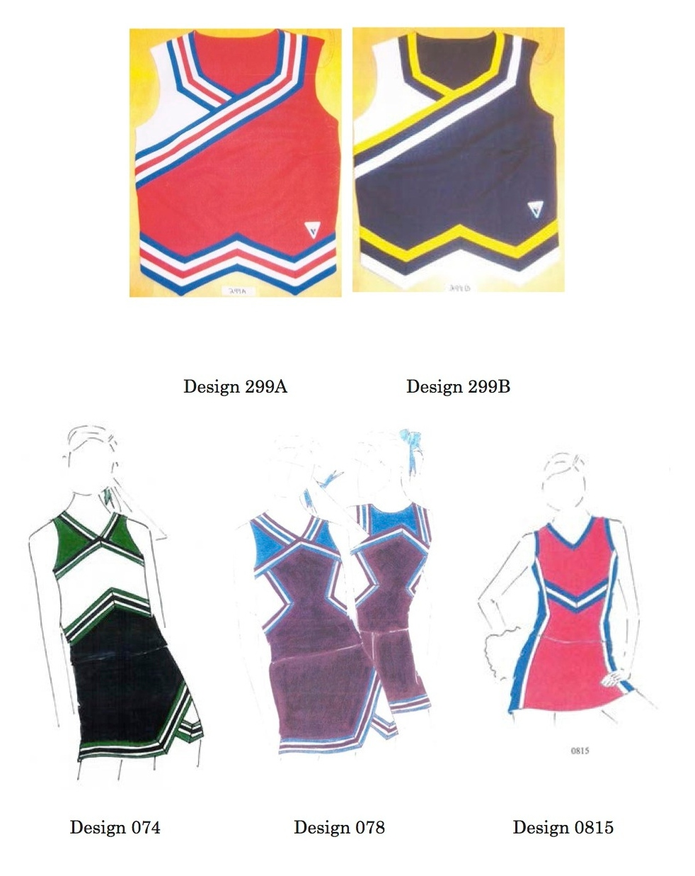
Petitioner Star Athletica, L.L.C., also markets and sells cheerleading uniforms. Respondents sued petitioner for infringing their copyrights in the five designs.

II

The first element of a copyright-infringement claim is “ownership of a valid copyright.” A valid copyright extends only to copyrightable subject matter.~
The Copyright Act~ establishes a special rule for copyrighting a pictorial, graphic, or sculptural work incorporated into a “useful article,” which is defined as “an article having an intrinsic utilitarian function that is not merely to portray the appearance of the article or to convey information.” The statute does not protect useful articles as such. Rather, “the design of a useful article” is “considered a pictorial, graphical, or sculptural work only if, and only to the extent that, such design incorporates pictorial, graphic, or sculptural features that can be identified separately from, and are capable of existing independently of, the utilitarian aspects of the article.”~ In this case, our task is to determine whether the arrangements of lines, chevrons, and colorful shapes appearing on the surface of respondents’ cheerleading uniforms are eligible for copyright protection as separable features of the design of those cheerleading uniforms.~
We must~ decide when a feature incorporated into a useful article “can be identified separately from” and is “capable of existing independently of” “the utilitarian aspects” of the article. This is not a free-ranging search for the best copyright policy, but rather “depends solely on statutory interpretation.” “The controlling principle in this case is the basic and unexceptional rule that courts must give effect to the clear meaning of statutes as written.” We thus begin and end our inquiry with the text, giving each word its “ordinary, contemporary, common meaning.”~
The statute provides that a “pictorial, graphic, or sculptural featur[e]” incorporated into the “design of a useful article” is eligible for copyright protection if it (1) “can be identified separately from,” and (2) is “capable of existing independently of, the utilitarian aspects of the article.” §101. The first requirement—separate identification—is not onerous. The decisionmaker need only be able to look at the useful article and spot some two- or three-dimensional element that appears to have pictorial, graphic, or sculptural qualities.
The independent-existence requirement is ordinarily more difficult to satisfy. The decisionmaker must determine that the separately identified feature has the capacity to exist apart from the utilitarian aspects of the article. In other words, the feature must be able to exist as its own pictorial, graphic, or sculptural work as defined in §101 once it is imagined apart from the useful article. If the feature is not capable of existing as a pictorial, graphic, or sculptural work once separated from the useful article, then it was not a pictorial, graphic, or sculptural feature of that article, but rather one of its utilitarian aspects.
Of course, to qualify as a pictorial, graphic, or sculptural work on its own, the feature cannot itself be a useful article or “[a]n article that is normally a part of a useful article” (which is itself considered a useful article). §101. Nor could someone claim a copyright in a useful article merely by creating a replica of that article in some other medium—for example, a cardboard model of a car. Al-though the replica could itself be copyrightable, it would not give rise to any rights in the useful article that inspired it.~
In sum, a feature of the design of a useful article is eligible for copyright if, when identified and imagined apart from the useful article, it would qualify as a pictorial, graphic, or sculptural work either on its own or when fixed in some other tangible medium.
Applying this test to the surface decorations on the cheerleading uniforms is straightforward. First, one can identify the decorations as features having pictorial, graphic, or sculptural qualities. Second, if the arrangement of colors, shapes, stripes, and chevrons on the surface of the cheerleading uniforms were separated from the uniform and applied in another medium—for example, on a painter’s canvas—they would qualify as “two-dimensional … works of … art,” §101. And imaginatively removing the surface decorations from the uniforms and applying them in another medium would not replicate the uniform itself. Indeed, respondents have applied the designs in this case to other media of expression—different types of clothing—without replicating the uniform. The decorations are therefore separable from the uniforms and eligible for copyright protection.
The dissent argues that the designs are not separable because imaginatively removing them from the uniforms and placing them in some other medium of expression—a canvas, for example—would create “pictures of cheerleader uniforms.” Petitioner similarly argues that the decorations cannot be copyrighted because, even when extracted from the useful article,they retain the outline of a cheerleading uniform.
This is not a bar to copyright. Just as two-dimensional fine art corresponds to the shape of the canvas on which it is painted, two-dimensional applied art correlates to the contours of the article on which it is applied. A fresco painted on a wall, ceiling panel, or dome would not lose copyright protection, for example, simply because it was designed to track the dimensions of the surface on which it was painted. Or consider, for example, a design etched or painted on the surface of a guitar. If that entire design is imaginatively removed from the guitar’s surface and placed on an album cover, it would still resemble the shape of a guitar. But the image on the cover does not “replicate” the guitar as a useful article. Rather, the design is a two-dimensional work of art that corresponds to the shape of the useful article to which it was applied. The statute protects that work of art whether it is first drawn on the album cover and then applied to the guitar’s surface, or vice versa. Failing to protect that art would create an anomaly: It would extend protection to two-dimensional designs that cover a part of a useful article but would not protect the same design if it covered the entire article. The statute does not support that distinction, nor can it be reconciled with the dissent’s recognition that “artwork printed on a t-shirt” could be protected.
To be clear, the only feature of the cheerleading uniform eligible for a copyright in this case is the two-dimensional work of art fixed in the tangible medium of the uniform fabric. Even if respondents ultimately succeed in establishing a valid copyright in the surface decorations at issue here, respondents have no right to prohibit any person from manufacturing a cheerleading uniform of identical shape, cut, and dimensions to the ones on which the decorations in this case appear. They may prohibit only the reproduction of the surface designs in any tangible medium of expression—a uniform or otherwise.~
According to petitioner, if a feature of a useful article “advance[s] the utility of the article,” then it is categorically beyond the scope of copyright. The designs here are not protected, it argues, because they are necessary to two of the uniforms’ “inherent, essential, or natural functions”—identifying the wearer as a cheerleader and enhancing the wearer’s physical appearance. Because the uniforms would not be equally useful without the designs, petitioner contends that the designs are inseparable from the “utilitarian aspects” of the uniform.
The Government~ suggests that the appropriate test is whether the useful article with the artistic feature removed would “remai[n] similarly useful.” In the view of the United States, however, a plain white cheerleading uniform is “similarly useful” to uniforms with respondents’ designs.
The debate over the relative utility of a plain white cheerleading uniform is unnecessary. The focus of the separability inquiry is on the extracted feature and not on any aspects of the useful article that remain after the imaginary extraction. The statute does not require the decisionmaker to imagine a fully functioning useful article without the artistic feature. Instead, it requires that the separated feature qualify as a nonuseful pictorial, graphic, or sculptural work on its own.
Of course, because the removed feature may not be a useful article—as it would then not qualify as a pictorial, graphic, or sculptural work—there necessarily would be some aspects of the original useful article “left behind” if the feature were conceptually removed. But the statute does not require the imagined remainder to be a fully functioning useful article at all, much less an equally useful one.~
Because we reject the view that a useful article must remain after the artistic feature has been imaginatively separated from the article, we necessarily abandon the distinction between “physical” and “conceptual” separability, which some courts and commentators have adopted based on the Copyright Act’s legislative history.~
The statutory text indicates that separability is a conceptual undertaking. Because separability does not require the underlying useful article to remain, the physical-conceptual distinction is unnecessary.

2

Petitioner next argues that we should incorporate two “objective” components into our test to provide guidance to the lower courts: (1) “whether the design elements can be identified as reflecting the designer’s artistic judgment exercised independently of functional influence,” and (2) whether “there is [a] substantial likelihood that the pictorial, graphic, or sculptural feature would still be marketable to some significant segment of the community without its utilitarian function.”
We reject this argument because neither consideration is grounded in the text of the statute.~ The statute’s text makes clear~ that our inquiry is limited to how the article and feature are perceived, not how or why they were designed. See Brandir Int’l, Inc. v. Cascade Pacific Lumber Co., 834 F. 2d 1142, 1152 (CA2 1987) (Winter, J., concurring in part and dissenting in part) (The statute “expressly states that the legal test is how the final article is perceived, not how it was developed through various stages”).
The same is true of marketability. Nothing in the statute suggests that copyrightability depends on market surveys. Moreover, asking whether some segment of the market would be interested in a given work threatens to prize popular art over other forms, or to substitute judicial aesthetic preferences for the policy choices embodied in the Copyright Act.

3

Finally, petitioner argues that allowing the surface decorations to qualify as a “work of authorship” is inconsistent with Congress’ intent to entirely exclude industrial design from copyright. Petitioner notes that Congress refused to pass a provision that would have provided limited copyright protection for industrial designs, including clothing, when it enacted the 1976 Act and that it has enacted laws protecting designs for specific useful articles—semiconductor chips and boat hulls—while declining to enact other industrial design statutes. From this history of failed legislation petitioner reasons that Congress intends to channel intellectual property claims for industrial design into design patents. It therefore urges us to approach this question with a presumption against copyrightability
We do not share petitioner’s concern. As an initial matter, “[c]ongressional inaction lacks persuasive significance” in most circumstances. Moreover, we have long held that design patent and copyright are not mutually exclusive.~ In any event, as explained above, our test does not render the shape, cut, and physical dimensions of the cheerleading uniforms eligible for copyright protection.~

Justice Ginsburg, concurring in the judgment.
I concur in the Court’s judgment but not in its opinion. Unlike the majority, I would not take up in this case the separability test appropriate under 17 U.S.C. §101. Consideration of that test is unwarranted because the designs at issue are not designs of useful articles. Instead, the designs are themselves copyrightable pictorial or graphic works reproduced on useful articles.
The designs here in controversy are standalone pictorial and graphic works that respondents Varsity Brands~ reproduce on cheerleading uniforms. Varsity’s designs first appeared as pictorial and graphic works that Varsity’s design team sketched on paper. Varsity then sought copyright protection for those two-dimensional designs, not for cheerleading costumes; its registration statements claimed “2-Dimensional artwork” and “fabric design (artwork).” Varsity next reproduced its two-dimensional graphic designs on cheerleading uniforms, also on other garments, including T-shirts and jackets.
In short, Varsity’s designs~ are standalone PGS works that may gain copyright protection as such, including the exclusive right to reproduce the designs on useful articles.

Justice Breyer, with whom Justice Kennedy joins, dissenting.
I agree with much in the Court’s opinion. But I do not agree that the designs that Varsity Brands, Inc., submitted to the Copyright Office are eligible for copyright protection. Even applying the majority’s test, the designs cannot “be perceived as … two- or three-dimensional work[s] of art separate from the useful article.”
Look at the designs that Varsity submitted to the Copyright Office. You will see only pictures of cheerleader uniforms. And cheerleader uniforms are useful articles. A picture of the relevant design features, whether separately “perceived” on paper or in the imagination, is a picture of, and thereby “replicate[s],” the underlying useful article of which they are a part. Hence the design features that Varsity seeks to protect are not “capable of existing independently o[f] the utilitarian aspects of the article.” 17 U.S.C. §101.

I

The relevant statutory provision says that the “design of a useful article” is copyrightable “only if, and only to the extent that, such design incorporates pictorial, graphic, or sculptural features that can be identified separately from, and are capable of existing independently of, the utilitarian aspects of the article.” But what, we must ask, do the words “identified separately” mean?~ The most direct, helpful aspect of the Court’s opinion answers this question by stating:
“Nor could someone claim a copyright in a useful article merely by creating a replica of that article in some other medium—for example, a cardboard model of a car. Although the replica could itself be copyright-able, it would not give rise to any rights in the useful article that inspired it.”
Exactly so. These words help explain the Court’s statement that a copyrightable work of art must be “perceived as a two- or three-dimensional work of art separate from the useful article.” They help clarify the concept of separateness. They are consistent with Congress’ own expressed intent.~
Consider, for example, the explanation that the House Report for the Copyright Act of 1976 provides. It says:
“Unless the shape of an automobile, airplane, ladies’ dress, food processor, television set, or any other industrial product contains some element that, physically or conceptually, can be identified as separable from the utilitarian aspects of that article, the design would not be copyrighted … .” H. R. Rep., at 55 (emphasis added).
These words suggest two exercises, one physical, one mental. Can the design features (the picture, the graphic, the sculpture) be physically removed from the article (and considered separately), all the while leaving the fully functioning utilitarian object in place? If not, can one nonetheless conceive of the design features separately without replicating a picture of the utilitarian object? If the answer to either of these questions is “yes,” then the design is eligible for copyright protection. Otherwise, it is not.~
An example will help. Imagine a lamp with a circular marble base, a vertical 10-inch tall brass rod (containing wires) inserted off center on the base, a light bulb fixture emerging from the top of the brass rod, and a lampshade sitting on top. In front of the brass rod a porcelain Siamese cat sits on the base facing outward. Obviously, the Siamese cat is physically separate from the lamp, as it could be easily removed while leaving both cat and lamp intact. And, assuming it otherwise qualifies, the designed cat is eligible for copyright protection.
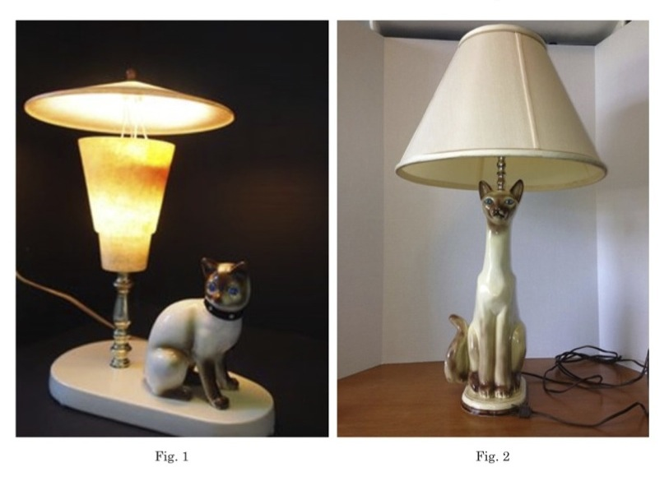
Now suppose there is no long brass rod; instead the cat sits in the middle of the base and the wires run up through the cat to the bulbs. The cat is not physically separate from the lamp, as the reality of the lamp’s construction is such that an effort to physically separate the cat and lamp will destroy both cat and lamp. The two are integrated into a single functional object, like the similar configuration of the ballet dancer statuettes that formed the lamp bases at issue in Mazer v. Stein, 347 U.S. 201 (1954). But we can easily imagine the cat on its own, as did Congress when conceptualizing the ballet dancer. See H.R. Rep., at 55 (the statuette in Mazer was “incorporated into a product without losing its ability to exist independently as a work of art”). In doing so, we do not create a mental picture of a lamp (or, in the Court’s words, a “replica” of the lamp), which is a useful article. We simply perceive the cat separately, as a small cat figurine that could be a copyrightable design work standing alone that does not replicate the lamp. Hence the cat is conceptually separate from the utilitarian article that is the lamp. The pair of lamps pictured at Figures 1 and 2~ illustrate this principle.~
By way of contrast, Van Gogh’s painting of a pair of old shoes, though beautifully executed and copyrightable as a painting, would not qualify for a shoe design copyright. See~ fig. 3~. Courts have similarly denied copyright protection to objects that begin as three-dimensional designs, such as measuring spoons shaped like heart-tipped arrows, candleholders shaped like sailboats, and wire spokes on a wheel cover. None of these designs could qualify for copyright protection that would prevent others from selling spoons, candleholders, or wheel covers with the same design. Why not? Because in each case the design is not separable from the utilitarian aspects of the object to which it relates. The designs cannot be physically separated because they themselves make up the shape of the spoon, candleholders, or wheel covers of which they are a part.~ [O]ne cannot easily imagine or otherwise conceptualize the design of the spoons or the candleholders or the shoes without that picture, or image, or replica being a picture of spoons, or candleholders, or wheel covers, or shoes. The designs necessarily bring along the underlying utilitarian object. Hence each design is not conceptually separable from the physical useful object.~
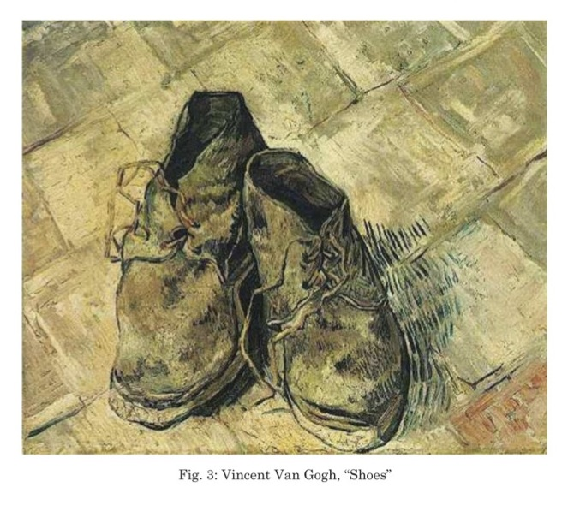
To repeat: A separable design feature must be “capable of existing independently” of the useful article as a separate artistic work that is not itself the useful article. If the claimed feature could be extracted without replicating the useful article of which it is a part, and the result would be a copyrightable artistic work standing alone, then there is a separable design. But if extracting the claimed features would necessarily bring along the underlying useful article, the design is not separable from the useful article. In many or most cases, to decide whether a design or artistic feature of a useful article is conceptually separate from the article itself, it is enough to imagine the feature on its own and ask, “Have I created a picture of a (useful part of a) useful article?” If so, the design is not separable from the useful article. If not, it is.
In referring to imagined pictures and the like, I am not speaking technically. I am simply trying to explain an intuitive idea of what separation is about, as well as how I understand the majority’s opinion. So understood, the opinion puts design copyrights in their rightful place. The law has long recognized that drawings or photographs of real world objects are copyrightable as drawings or photographs, but the copyright does not give protection against others making the underlying useful objects. That is why a copyright on Van Gogh’s painting would prevent others from reproducing that painting, but it would not prevent others from reproducing and selling the comfortable old shoes that the painting depicts.~

II

To ask this kind of simple question—does the design picture the useful article?—will not provide an answer in every case, for there will be cases where it is difficult to say whether a picture of the design is, or is not, also a picture of the useful article. But the question will avoid courts focusing primarily upon what I believe is an unhelpful feature of the inquiry, namely, whether the design can be imagined as a “two- or three-dimensional work of art.” That is because virtually any industrial design can be thought of separately as a “work of art”: Just imagine a frame surrounding the design, or its being placed in a gallery. Consider Marcel Duchamp’s “readymades” series, the functional mass-produced objects he designated as art. See~ fig. 4, [picture of shovel].~ What design features could not be imaginatively reproduced on a painter’s canvas?~
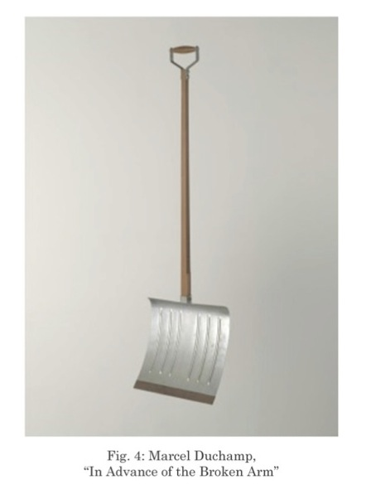
III

The conceptual approach that I have described reflects Congress’ answer to a problem that is primarily practical and economic. Years ago Lord Macaulay drew attention to the problem when he described copyright in books as a “tax on readers for the purpose of giving a bounty to writers.” He called attention to the main benefit of copyright protection, which is to provide an incentive to produce copyrightable works and thereby “promote the Progress of Science and useful Arts.” But Macaulay also made clear that copyright protection imposes costs. Those costs include the higher prices that can accompany the grant of a copyright monopoly. They also can include (for those wishing to display, sell, or perform a design, film, work of art, or piece of music, for example) the costs of discovering whether there are previous copyrights, of contacting copyright holders, and of securing permission to copy. Sometimes, as Thomas Jefferson wrote to James Madison, costs can outweigh “the benefit even of limited monopolies.” And that is particularly true in light of the fact that Congress has extended the “limited Times” of protection, from the “14 years” of Jefferson’s day to potentially more than a century today.
The Constitution grants Congress primary responsibility for assessing comparative costs and benefits and drawing copyright’s statutory lines. Courts must respect those lines and not grant copyright protection where Congress has decided not to do so. And it is clear that Congress has not extended broad copyright protection to the fashion design industry. See, e.g., 1 Nimmer §2A.08[H][3][c] (describing how Congress rejected proposals for fashion design protection within the 1976 Act and has rejected every proposed bill to this effect since then); Esquire, Inc. v. Ringer, 591 F. 2d 796, 800, n. 12 (CADC 1978) (observing that at the time of the 1976 Copyright Act, Congress had rejected every one of the approximately 70 design protection bills that had been introduced since 1914)~.
Congress’ decision not to grant full copyright protection to the fashion industry has not left the industry without protection. Patent design protection is available. A maker of clothing can obtain trademark protection under the Lanham Act for signature features of the clothing. And a designer who creates an original textile design can receive copyright protection for that pattern as placed, for example, on a bolt of cloth, or anything made with that cloth.
The fashion industry has thrived against this backdrop, and designers have contributed immeasurably to artistic and personal self-expression through clothing. But a decision by this Court to grant protection to the design of a garment would grant the designer protection that Congress refused to provide. It would risk increased prices and unforeseeable disruption in the clothing industry, which in the United States alone encompasses nearly $370 billion in annual spending and 1.8 million jobs. That is why I believe it important to emphasize those parts of the Court’s opinion that limit the scope of its interpretation. That language, as I have said, makes clear that one may not “claim a copyright in a useful article merely by creating a replica of that article in some other medium,” which “would not give rise to any rights in the useful article that inspired it.”

IV

If we ask the “separateness” question correctly, the answer here is not difficult to find. The majority’s opinion, in its appendix, depicts the cheerleader dress designs that Varsity submitted to the Copyright Office. Can the design features in Varsity’s pictures exist separately from the utilitarian aspects of a dress? Can we extract those features as copyrightable design works standing alone, without bringing along, via picture or design, the dresses of which they constitute a part?
Consider designs 074, 078, and 0815. They certainly look like cheerleader uniforms. That is to say, they look like pictures of cheerleader uniforms, just like Van Gogh’s old shoes look like shoes. I do not see how one could see them otherwise. Designs 299A and 2999B present slightly closer questions. They omit some of the dresslike context that the other designs possess. But the necklines, the sleeves, and the cut of the skirt suggest that they too are pictures of dresses. Looking at all five of Varsity’s pictures, I do not see how one could conceptualize the design features in a way that does not picture, not just artistic designs, but dresses as well.
Were I to accept the majority’s invitation to “imaginatively remov[e]” the chevrons and stripes as they are arranged on the neckline, waistline, sleeves, and skirt of each uniform, and apply them on a “painter’s canvas,” that painting would be of a cheerleader’s dress. The esthetic elements on which Varsity seeks protection exist only as part of the uniform design—there is nothing to separate out but for dress-shaped lines that replicate the cut and style of the uniforms. Hence, each design is not physically separate, nor is it conceptually separate, from the useful article it depicts, namely, a cheerleader’s dress. They cannot be copyrighted.
Varsity, of course, could have sought a design patent for its designs. Or, it could have sought a copyright on a textile design, even one with a similar theme of chevrons and lines.
But that is not the nature of Varsity’s copyright claim. It has instead claimed ownership of the particular “ ‘treatment and arrangement’ ” of the chevrons and lines of the design as they appear at the neckline, waist, skirt, sleeves, and overall cut of each uniform. The majority imagines that Varsity submitted something different—that is, only the surface decorations of chevrons and stripes, as in a textile design. As the majority sees it, Varsity’s copyright claim would be the same had it submitted a plain rectangular space depicting chevrons and stripes, like swaths from a bolt of fabric. But considered on their own, the simple stripes are plainly unoriginal. Varsity, then, seeks to do indirectly what it cannot do directly: bring along the design and cut of the dresses by seeking to protect surface decorations whose “treatment and arrangement” are coextensive with that design and cut. As Varsity would have it, it would prevent its competitors from making useful three-dimensional cheerleader uniforms by submitting plainly unoriginal chevrons and stripes as cut and arranged on a useful article. But with that cut and arrangement, the resulting pictures on which Varsity seeks protection do not simply depict designs. They depict clothing. They depict the useful articles of which the designs are inextricable parts. And Varsity cannot obtain copyright protection that would give them the power to prevent others from making those useful uniforms, any more than Van Gogh can copyright comfortable old shoes by painting their likeness.
I fear that, in looking past the three-dimensional design inherent in Varsity’s claim by treating it as if it were no more than a design for a bolt of cloth, the majority has lost sight of its own important limiting principle. One may not “claim a copyright in a useful article merely by creating a replica of that article in some other medium,” such as in a picture. That is to say, one cannot obtain a copyright that would give its holder “any rights in the useful article that inspired it.”
With respect, I dissent.

We do not today hold that the surface decorations are copyrightable. We express no opinion on whether these works are sufficiently original to qualify for copyright protection, see Feist Publications, Inc. v. Rural Telephone Service Co., 499 U.S. 340–359 (1991), or on whether any other prerequisite of a valid copyright has been satisfied.
The dissent suggests that our test would lead to the copyrighting of shovels. But a shovel, like a cheerleading uniform, even if displayed in an art gallery, is “an article having an intrinsic utilitarian function that is not merely to portray the appearance of the article or to convey information.” 17 U.S.C. §101. It therefore cannot be copyrighted. A drawing of a shovel could, of course, be copyrighted. And, if the shovel included any artistic features that could be perceived as art apart from the shovel, and which would qualify as protectable pictorial, graphic, or sculptural works on their own or in another medium, they too could be copyrighted. But a shovel as a shovel cannot.

